Discussion and Analysis

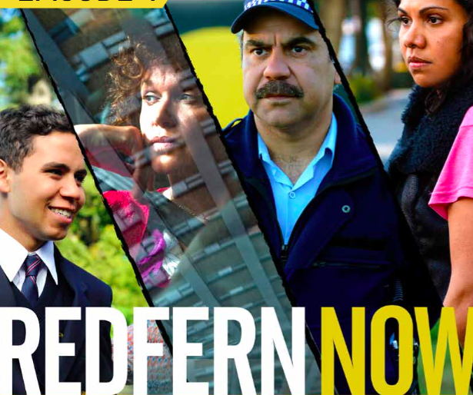

Student:

“Joyride” Key Scenes

Opening sequence: ‘Joyride’ begins at Coral’s house. When Coral discovers her pet budgie has died, she nudges it with her finger in the hope it might spring back to life. It doesn’t. Having wrapped up the bird and placed it in the kitchen bin, Coral grabs the cage, her handbag and walks out her front door.
On her way to the pet shop to buy another bird, Coral sees Teneka. Coral questions why Teneka is keeping company with some of the local louts and threatens to call her mother.
Elsewhere in the neighbourhood, teenage troublemakers Justin (Dimitri Baveas) and Korey (Jesse Guivarra) have stolen a car and are keen to go joyriding.
- What happens next and why is this the moment that changes everything?

- *What do we learn about Coral during the opening sequence of ‘Joyride’?

- What do we learn about Danny during the opening sequence of ‘Joyride’?

- What do we learn about Teneka during the opening sequence of ‘Joyride’?

- Examine the sequence in detail and give examples and explanations of key elements of construction.
FILM ELEMENTS | EXAMPLES AND MEANING
Camera shots and framing
Editing, transition from one shot to the next
Dialogue
Sound effects
Music
Depiction of characters within their physical environment
Symbols

6. Ending
‘Pick up, Julie. Julie, I know you’re there. Please pick up. If you come to the door, if you just give me five minutes at the door, I can explain everything. Just five minutes, please. Okay, I’ll do it over the phone. Look through the window. Can you see me?’ – Danny
Danny backs away from Coral’s front door and onto the road, so Julie can see him. He starts to explain, pleading with her not to cut him off. This is why he is in the path of the stolen vehicle being driven by Justin and Korey.
‘Joyride’ ends with Danny in hospital. Julie is by his bedside. Coral joins her and they discuss the future of Julie and Danny’s relationship.
- What happens next?

- What ideas are resolved in the closing scene?

- Was this the conclusion that you expected?

“Joyride” Issue

Issues – Discussion
Blackfella Films offer stories of Indigenous Australians told by Indigenous Australians. One aspect of this series is that it presents issues affecting an Indigenous Australian community from an Indigenous perspective. Consider what this means in the ways a mainstream audience may be challenged in their thinking about social issues.
Issue – Youth offenders
Indigenous juveniles are over-represented in the juvenile justice system and at all stages of the criminal justice system. Current statistics show that Indigenous juveniles are twenty-four times as likely to be detained in a juvenile correctional facility as non-Indigenous juveniles. There are many reasons why this is the case, including a lack of access to diversionary programs, systemic discrimination against Indigenous juveniles, inadequate resourcing of Aboriginal legal services, and genuinely higher levels of offending by Indigenous juveniles.
In “Joyride” the audience is presented with different perspectives of the issue of Indigenous juvenile crime. Danny is involved in crime and yet his character is quite sympathetic, Coral is a victim of crime, yet she believes in Taneka who is involved in crime. Aaron, the police officer, has to deal with young offenders and many others are affected.
Read the following text references and questions and discuss them in your group. Record brief notes on your discussion points. Consider your ideas about the views of each character on the issue of juvenile crime.
Text References and Questions | Notes
‘Nah, I wouldn’t risk it.’ – Danny
Danny’s mates Justin and Korey have stolen a car and want Danny to come joyriding. Danny refuses, claiming it is too risky, but gets in the car when they won’t take no for an answer.
- Despite knowing the right thing to do, Danny does the wrong thing. Why is this the case?
- Does Danny enjoy the ride?
Aaron: What the hell are you doing, Danny? You’re a decent boy. Why go to prison for a bunch of idiots? Danny: Hey they’re my mates.
Aaron: Mates. Hey, if they were your mates, they’d be here right now taking the blame. You phoned an ambulance, got yourself caught ’cause you were worried about her. Hey, that proves that you’re decent. They’re not, son. They’re bloody clowns. Believe me I know.
- How do the police respond to juvenile offenders in ‘Joyride’. Why is Constable Aaron Davis on Danny’s side?
After he is released from detention, Danny heads to Coral’s house with a big packet of birdseed. He wants to apologise.
- What evidence is there to suggest that it will not be easy for Danny to stay out of trouble?
‘Stay away from our men. Uptown nigger.’ – Teneka
- Why does Teneka punch Julie in the face?
When Danny confronts her, Teneka replies, ‘Felt like it.’ Danny challenges her non-committal response, ‘You felt like it? ... What ’cause she’s prettier than you? She’s nice and she’s pretty and she’s decent. I can’t have that? You wanna drag me down. You wanna pull me down in the shit ’cause you’re in the shit. What’d she do to you, huh? Nothin’!’
- Is Danny right? What does his remark reveal about what he wants for himself?
‘You’ve got a brain, child. You’ve got a future.’ – Coral
- Why does Coral express belief in Teneka?

“Perspective: A position from which things may be viewed or considered. People may have different perspectives on events or issues due to (for example) their age, gender, social position and beliefs and values. A perspective is more than an opinion; it is a viewpoint informed by one or more contexts.

Choose TWO of the characters from “Joyride” and explain what you think their perspective on juvenile crime might be. Give examples from the text to support your ideas.

Character 1:

Character 2:

